Agile projects 20th March recap and notes/week 2

Agile means flexible dynamic. The project is a process or system.  
When these are together it is a dynamic process.

SCRUM = sprints or iterations making up a whole. Each iteration will be about two to three weeks for projects

KANBAN = a Japanese practice that shows a streamline of processes. Such as to do, doing and done aligned in columns.

PROJECT LIFE CYCLE

Plan is not correct. It needs to iterate and be continuous. Always. The planning in our project is not one off, it is continuous. Main objective of planning is to increase collaboration. What’s the scope?   
Why does the project need closure? To start a new iteration. To start a new iteration, you to release from the first before starting the next.   
Initiation is important as it defines what we require in the project. It defines what the project will accomplish or complete.  
Execution is documentation deployment.

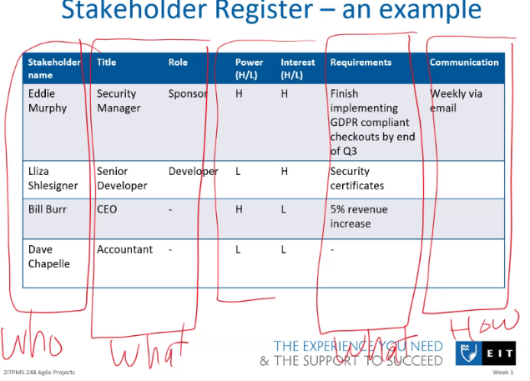ACTIVITY – Define stakeholder. Who is with us? What is their role? What is their requirement?  
We have different types of stakeholders

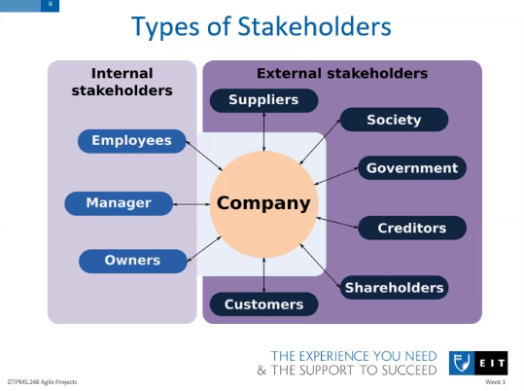

A stakeholder document is important to have since it is important to be able to identify the people, their requirements, and their role.

There are two different types of requirements. Functional and nonfunctional. Nonfunctional is a support role. Functional can include login.

PROJECT CHARTER is part of the initiation phase.

REQUIREMENTS(POSITIVE) Some are low level and some high level. The difference between these is that low is more technical or specific, whereas high level is more general or broad

LOW = such as a button and its purpose  
HIGH = an engaging interface such as material AI which is a framework.

Understand the vision and role for each person involved.   
An implementation plan outlines major milestones and dependencies. These are things that MUST be finished before continuing.

IRON TRIANGLE – MODEL OF CONSTRAINTS

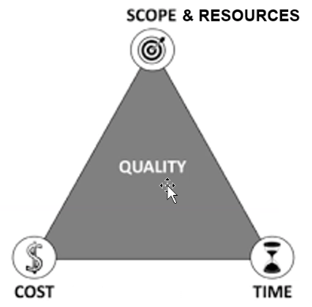Change in one side will affects the others.

What is most important for project success? The driver. Could be money, passion. What constraints are there? Floats are lower priority and flexible items.   
Ideally have 1 driver, 1 constraint and 4 floats  
eg.  
Driver = number one smartwatch sales in region. Top priority.  
  
Constraint = fast order processing(time)gives good brand or spend less money. This is second priority.  
Floats = increase user numbers, zero fees for payment, empower knowledge by having a help/support section, accessible. These are low priority.

Examples of constraints  
- Time and budget  
- interfaces to other systems  
- Laws eg GST  
- Physical size  
- user/operator capabilities  
- pre-existing technology

Use “shall” for requirements  
Use “should” for recommendations  
Use “may” for permissions/suggestions.

For legal reasons, avoid using “WILL.”

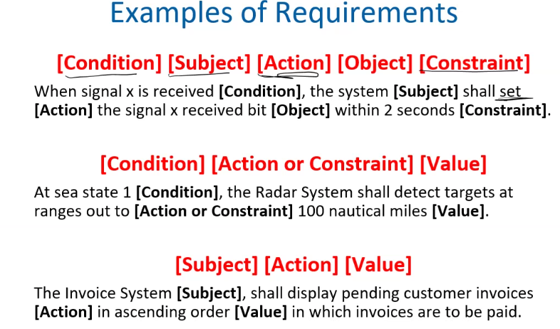

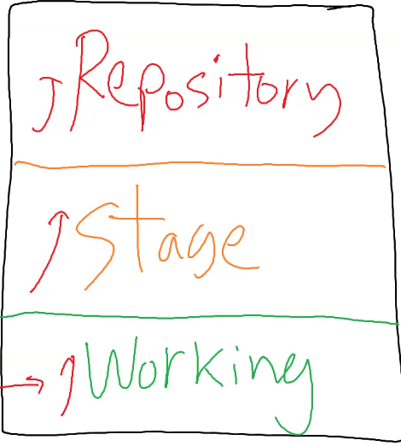

GIT AND VERSION CONTROL  
Version control refers to changes made to a file over time.  
Working = working on it and developing  
Stage = Initial document is complete  
Repository = No more changes can be made

When needing to edit and change, you  
must repeat the cycle again from green.  
Ensure the stages are clear for users.